NAME: B.GNANESWAR REDDY

REG.NO.: 192111448

Program 21:

NFA to accept start with a and end with b:

W=abaab

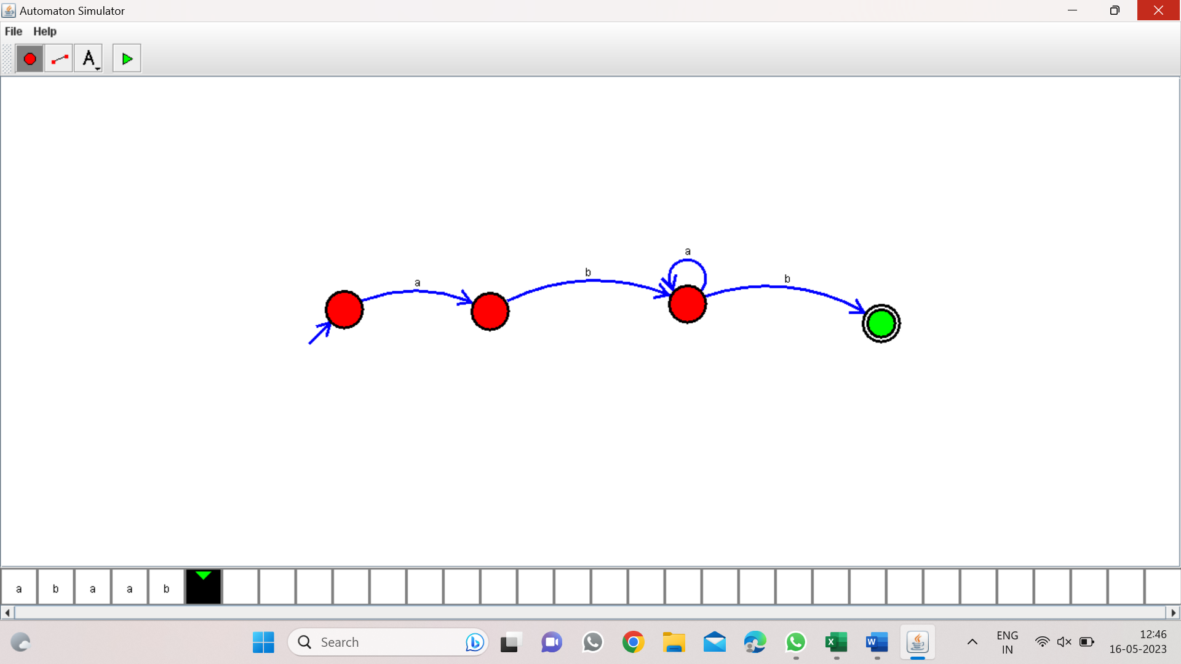

Program 22: 37

NFA to accept string that start and end with different symbols:

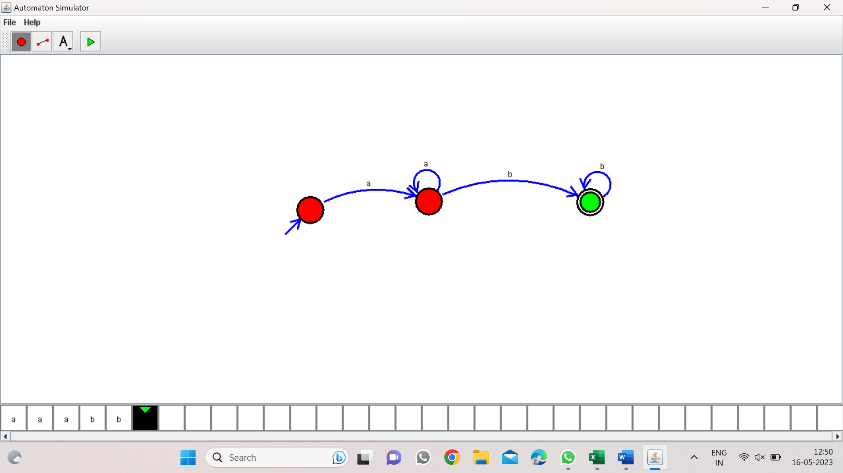

Program 23: 38

NFA to accept the string bbc,c,bcaaa:

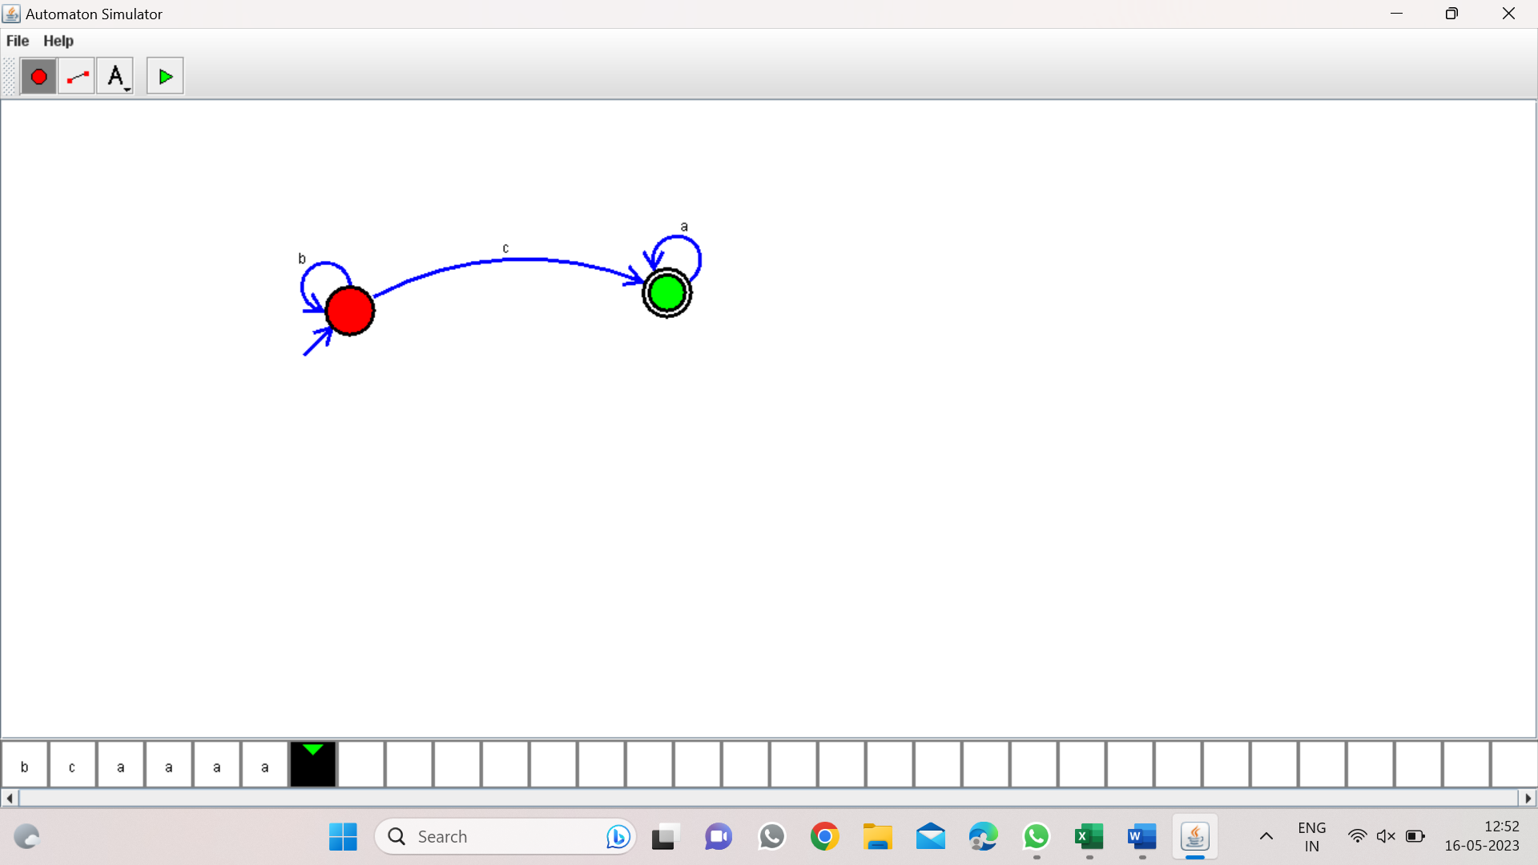

Program 24: 39

DFA to accept the string that end with abc:

W=abbaababc

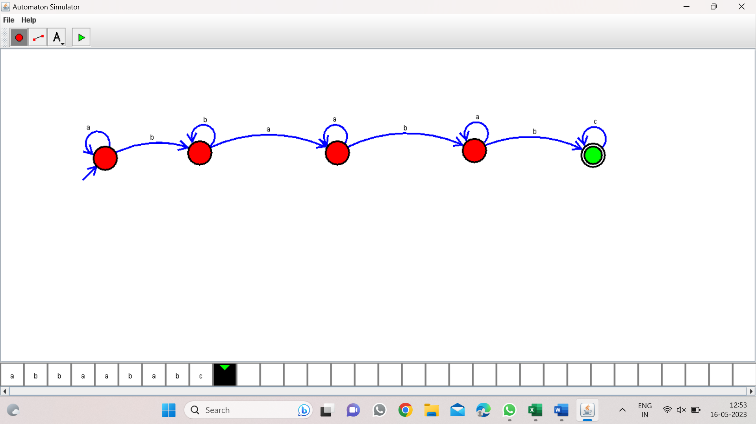

Program 25: 40

NFA to accept any number of b’s:

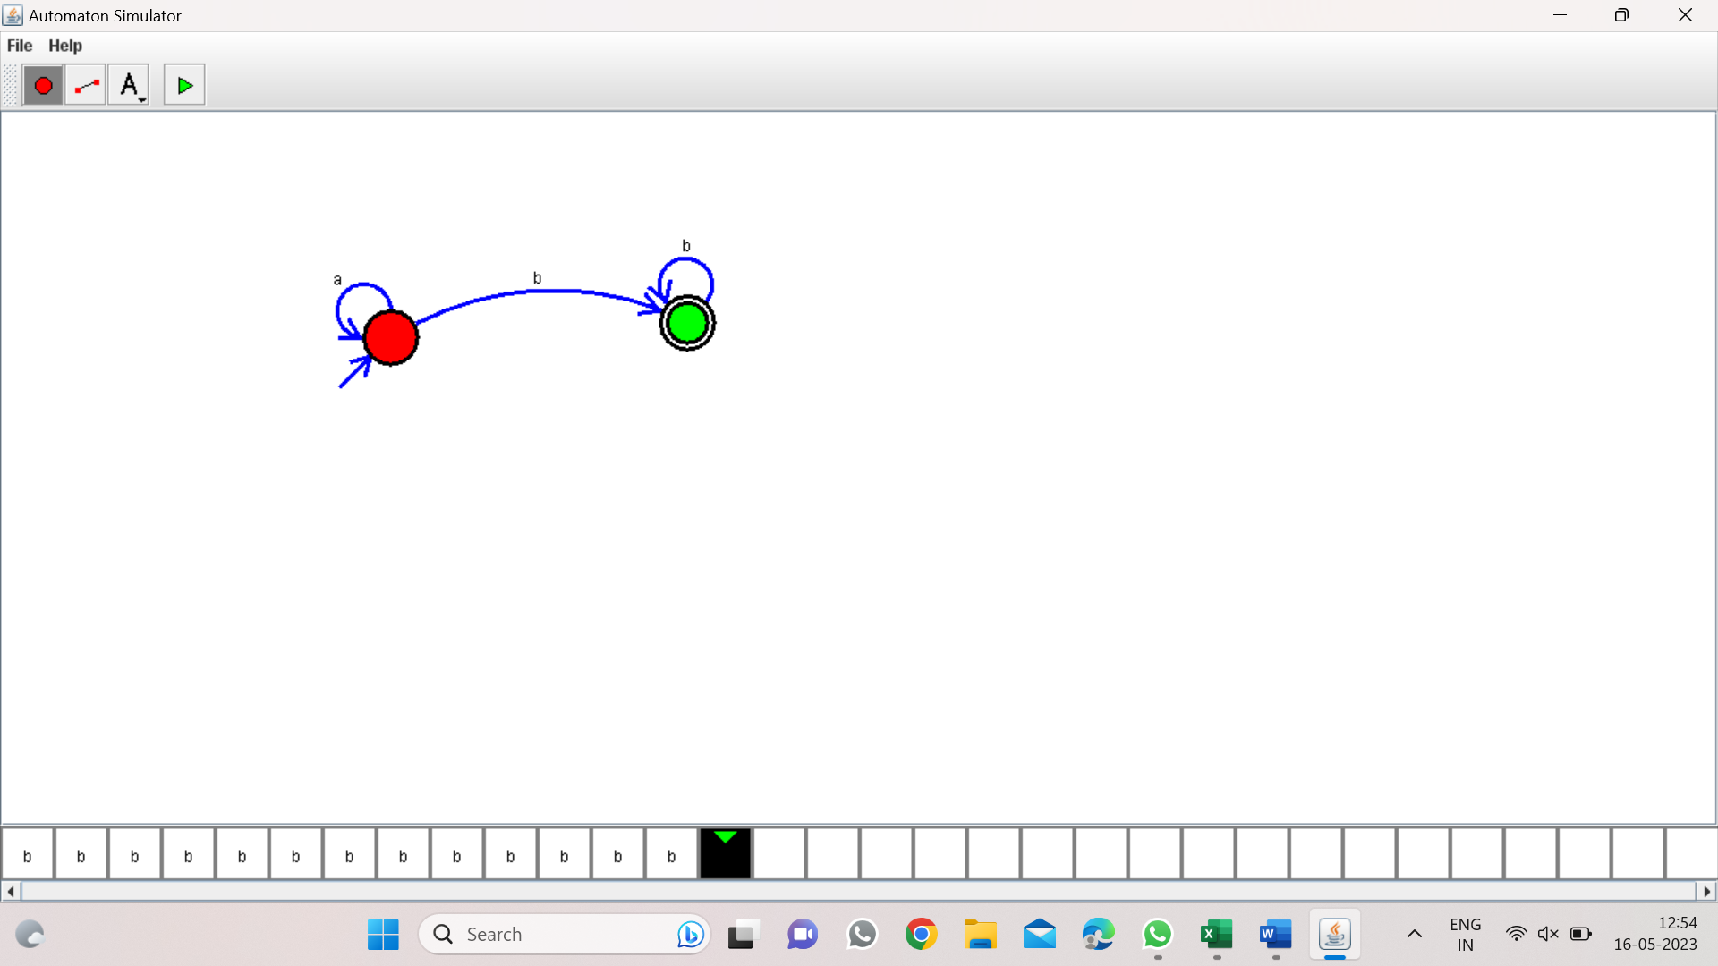

Program 26: 21

DFA for even no.of a’s:

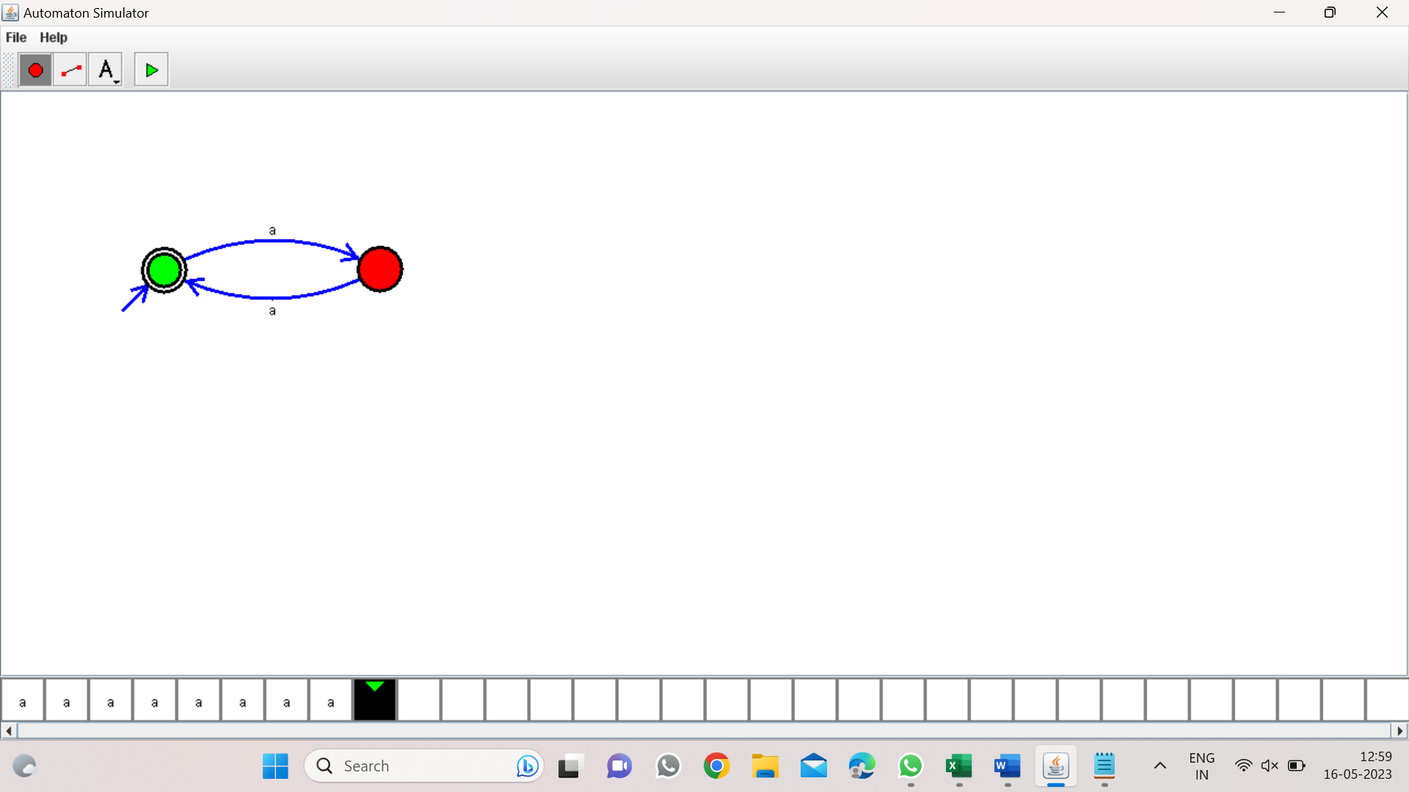

Program27: 22

DFA for odd no.of a’s:

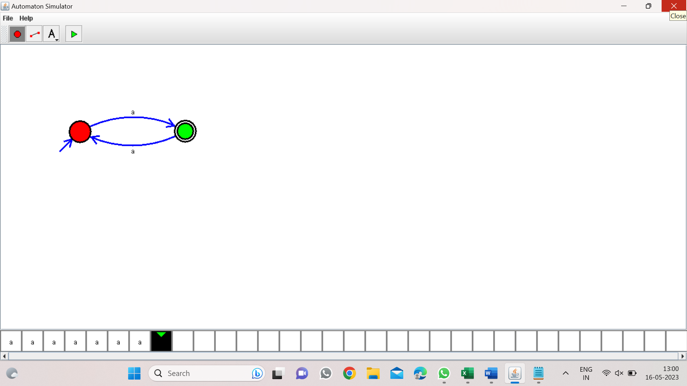

Program 28: 23

DFA to accept string end with ab:

W=aaabab:

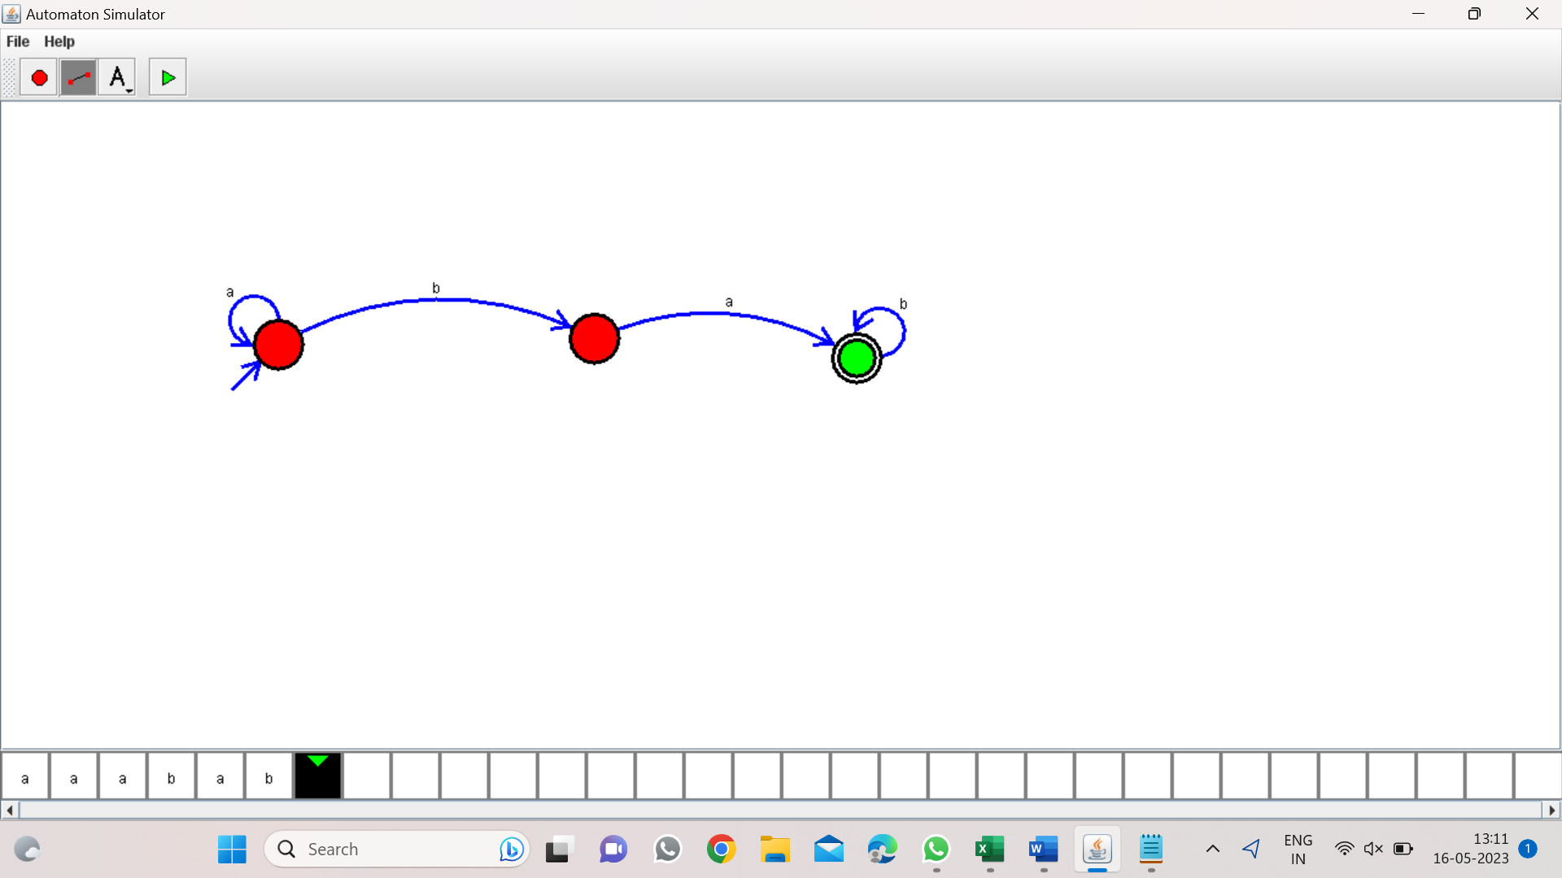

Program 29: 24

DFA consisting substring ab:

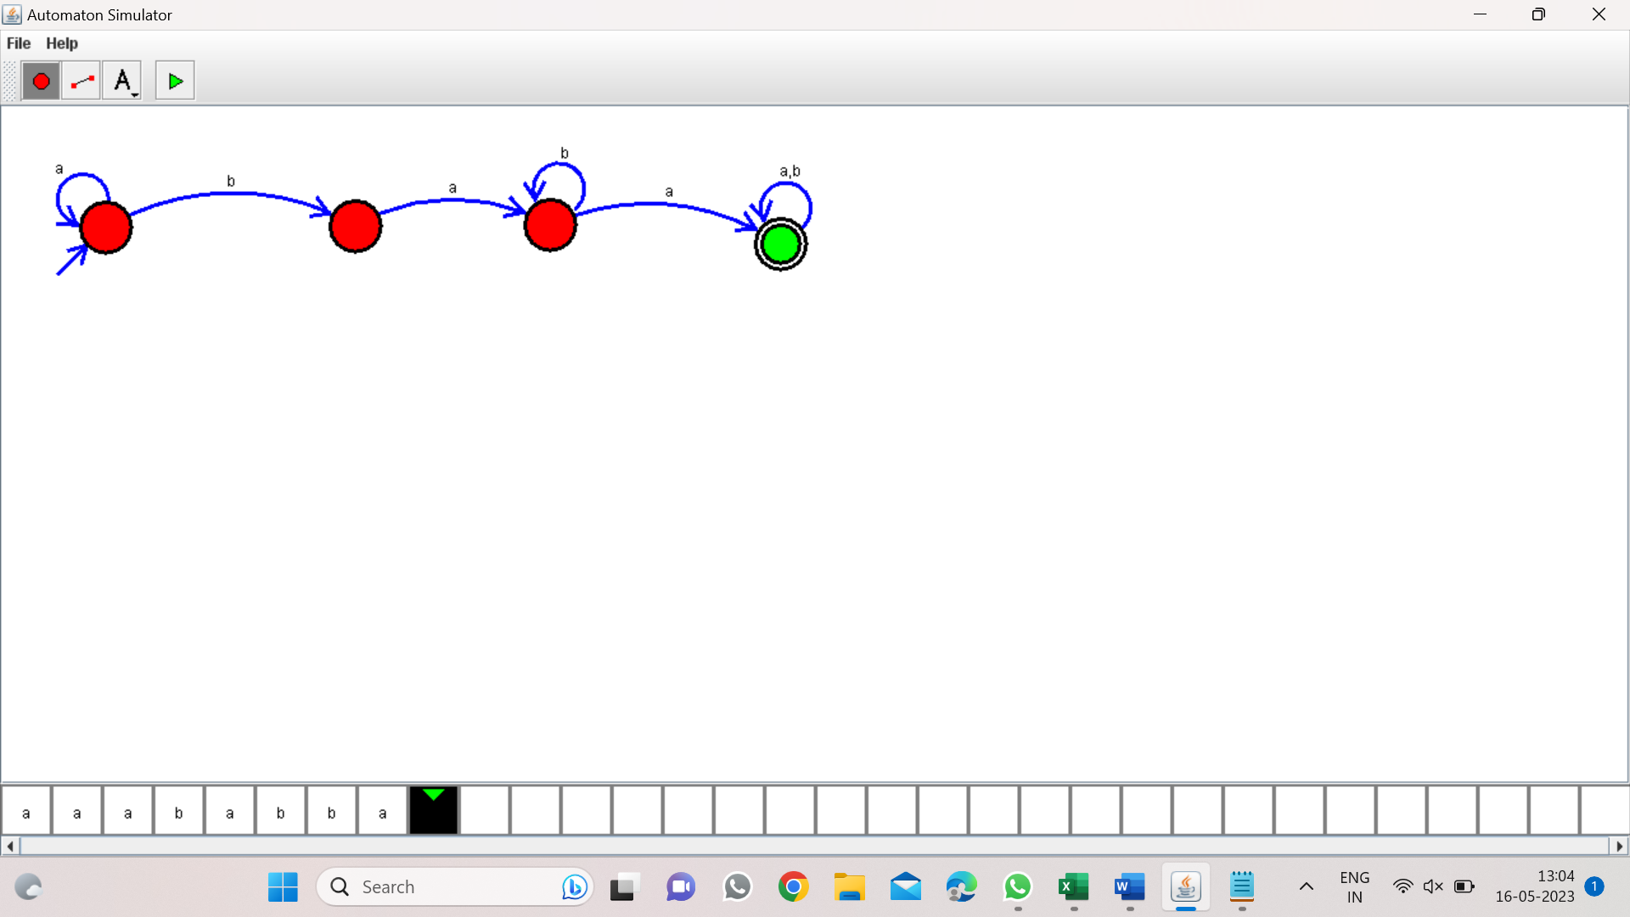

Program 30: 25

DFA start with a or b:

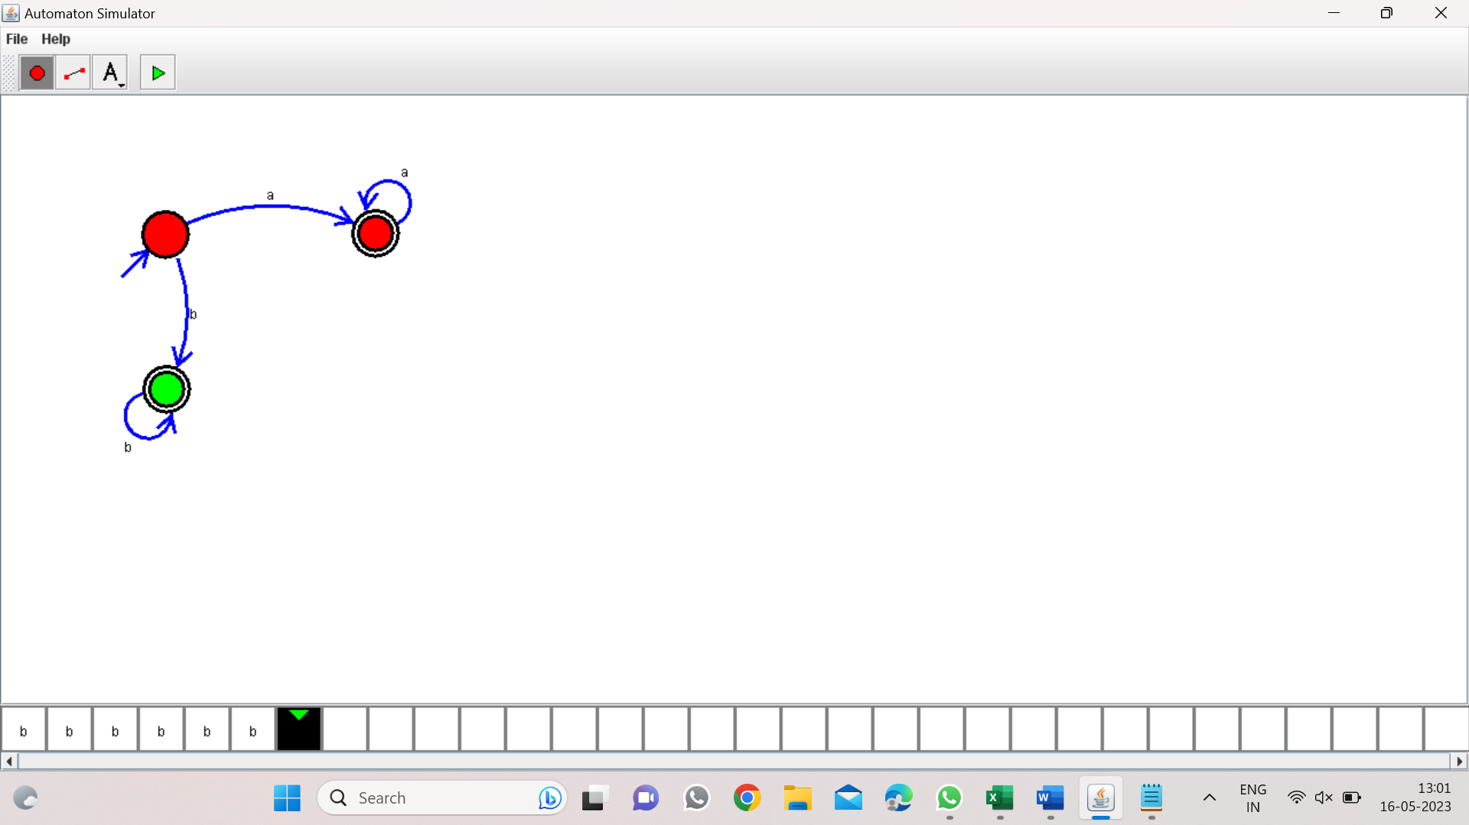

PROGRAM 31: 26

TM TO ACCEPT STRINNG PALINDROME (bbabb):

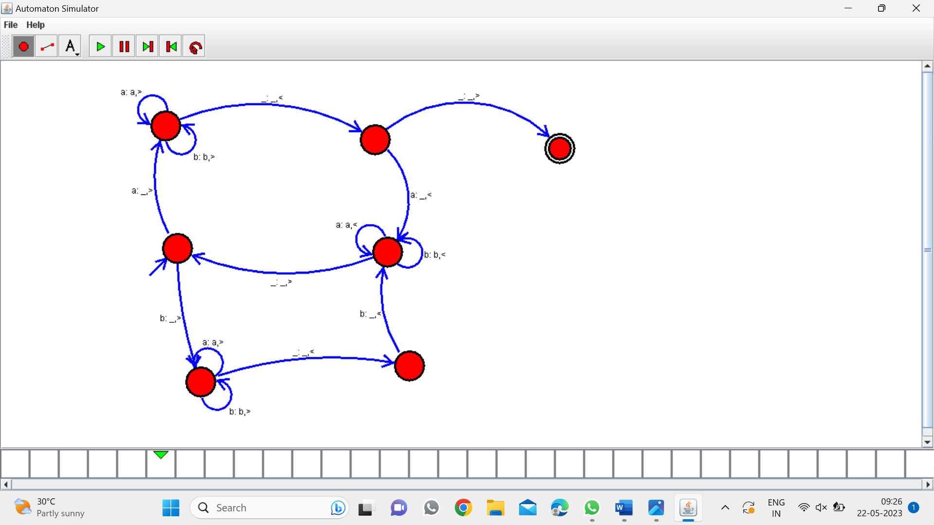

PROGRAM 32:

DFA TO ACCEPT EVEN NUMBER OF C’s: